|  |  |
| --- | --- |
| |  | | --- | | DevOps : Ansible Automation C:\Users\harish.haridas\AppData\Local\Microsoft\Windows\INetCache\Content.Word\ansible-logo.jpg | |
|  |
| Description: line.png  User Manual |

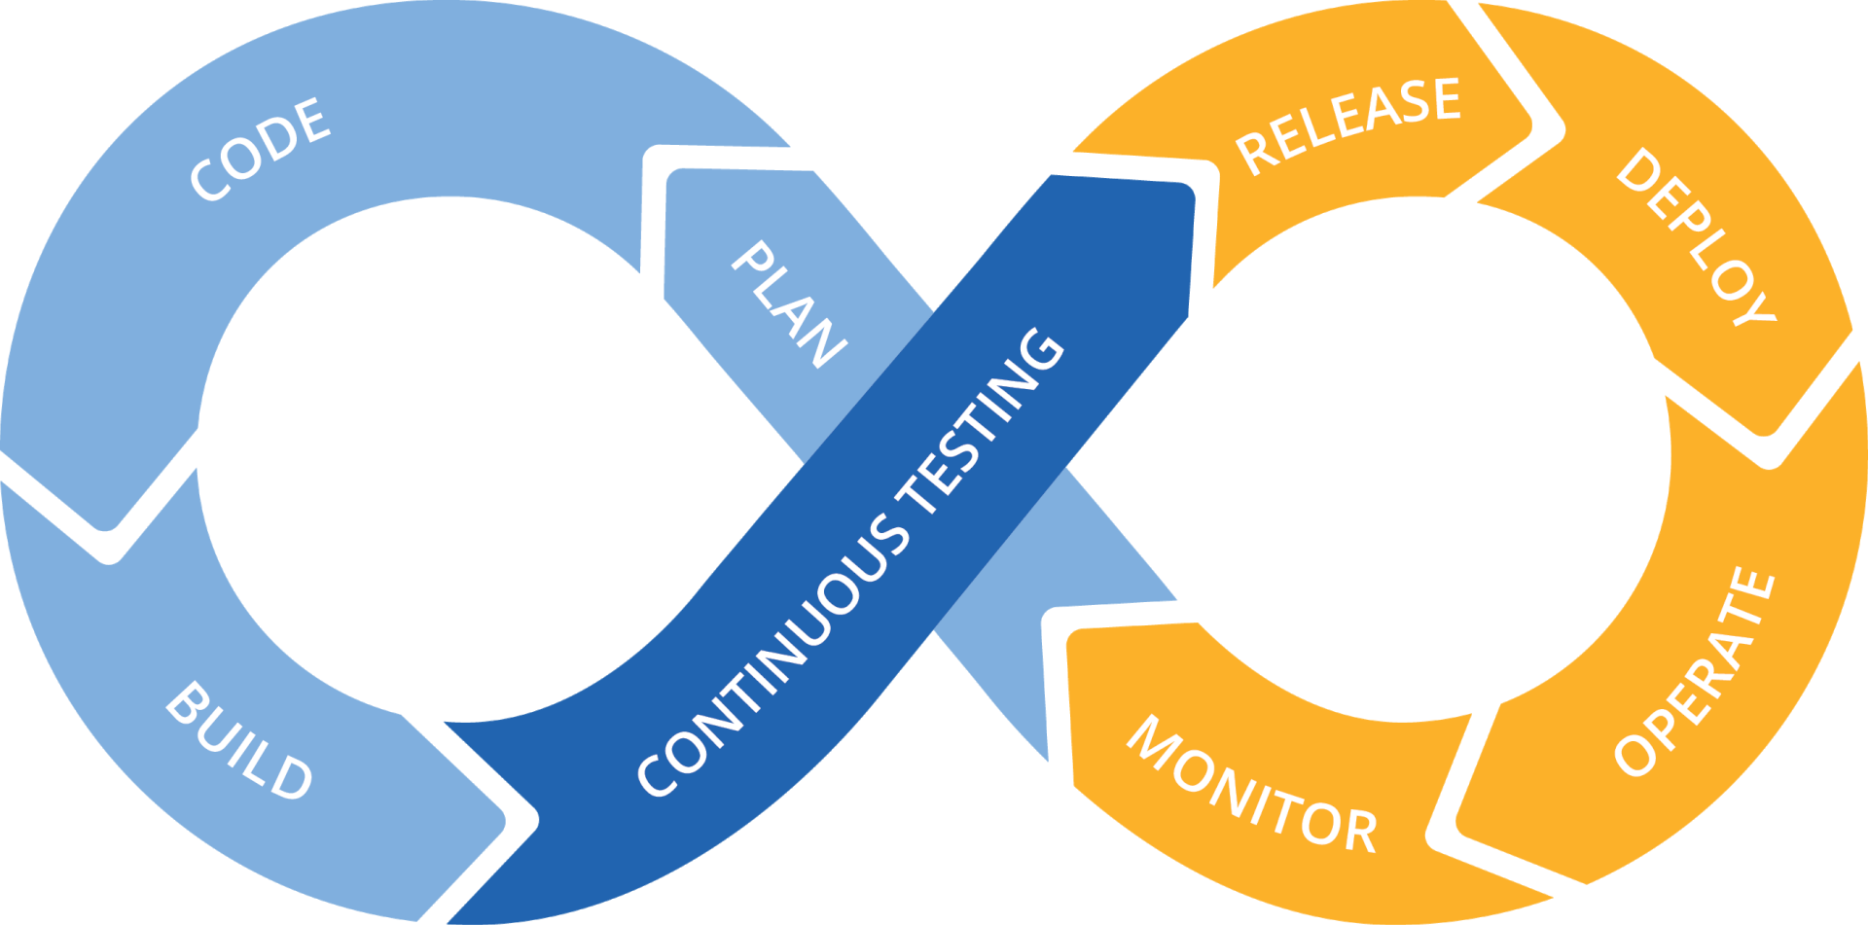

Abstract

This document named “DevOps – Ansible Automation“ will contain detailed steps to run Ansible Playbooks to automate Installation of Applications like MySQL in RHEL Server’s.

Disclaimer

This document is prone to amendments, improvements and corrections subject to any information that may be missing, wrongly presented or where improvement is required and necessary.

# Document revision history

|  |  |  |  |
| --- | --- | --- | --- |
| **Revision** | **Date** | **Prepared/Revised By** | **Description** |
| v1.0 | 2018-July-29 | Harish Haridas | Initial Draft |
|  |  |  |  |

# Distribution History

|  |  |  |
| --- | --- | --- |
| **Revision** | **Date** | **Distribution List** |
| v1.0 | 2018-July-29 | 6d Technologies |

# 

Contents

1 Who should read this document? 4

1.1 Introduction to Ansible 4

1.2 Why Ansible 4

1.3 Installation of Ansible 5

1.4 Ansible Pre-requisites 5

1.4.1 Create the RSA Key Pair 5

1.5 Steps Involved in Installing MySQL on RHEL 6

# Who should read this document?

This manual will explain steps to Install MySQL through Ansible on RHEL Servers. By reading this manual, you will learn steps of installation, configuration of Ansible and MySQL over RHEL

## Introduction to Ansible

Ansible is an IT automation platform that makes applications and systems easier to deploy.

It supports configuration management with examples as below:

* Configuration of servers
* Application deployment
* Provisioning
* Automation of tasks

## Why Ansible

* It is a free open source application
* Agent-less – No need for agent installation and management
* Python/yaml based
* Highly flexible and configuration management of systems.
* Large number of ready to use modules for system management
* Custom modules can be added if needed
* Configuration roll-back in case of error
* Simple and human readable
* Self-documenting
* 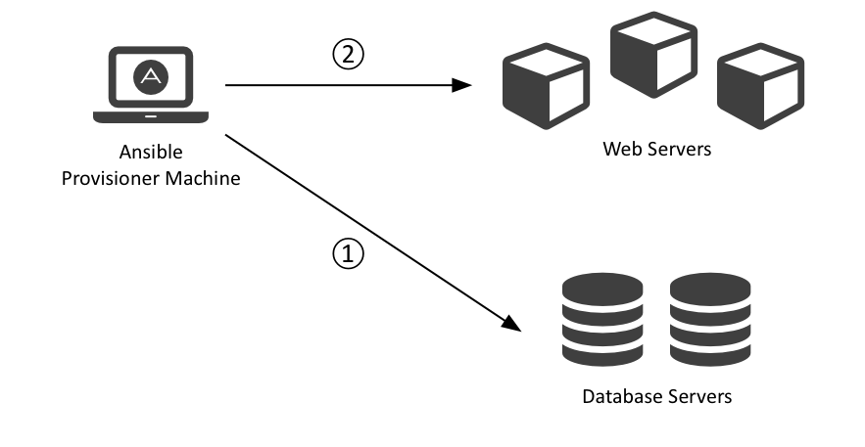

## Installation of Ansible

1. List packages to see if ansible & epel are available :

[harish@CENTOS1 ~]$ yum list | grep ansible

[harish@CENTOS1 ~]$ yum list | grep epel

1. Install noarch RPM

[harish@CENTOS1 ~]$ rpm -ivh epel-release-7-11.noarch.rpm

*[This will create epel.repo & epel-testing.repo in /etc/yum.repos.d]*

1. List packages again : yum list | grep ansible
2. Install epel and ansible packages using ‘yum’ command

[harish@CENTOS1 ~]$ yum install ansible

1. After Installation Check below command to see if ansible is installed properly

[harish@CENTOS1 ~]$ ansible –version

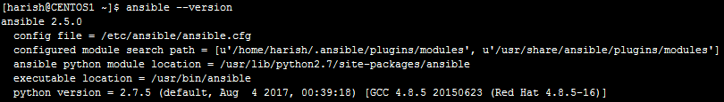

*Note: Check for other dependency packages missing, if any.*

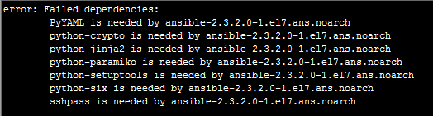

## Ansible pre-requisites

### Create the RSA Key Pair

1. The first step is to create the key pair on the Server machine

[harish@CENTOS1 ~]$ ssh-keygen –t rsa

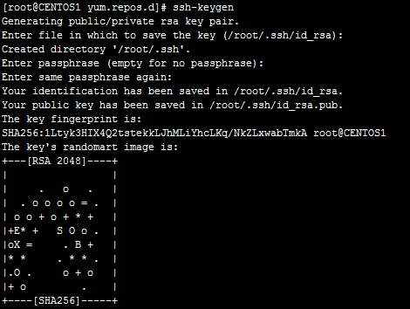

1. Save the generated key in Server Path (~/.ssh/id_rsa).
2. Copy the Public Key to all Client Machines

[root@CENTOS1 ~]# ssh-copy-id user@IP-address

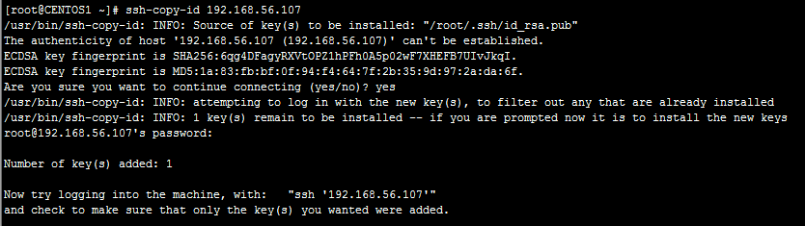

1. Ensure that the $username has sudo access to the remote clients
2. Try Login to Client Machines with ssh user@IP without password

### Configuration of Ansible

Do the following on the Server machine

* Create the list of client machines you wish to access via Ansible server

[harish@CENTOS1 ansible]$ vi /etc/ansible/hosts

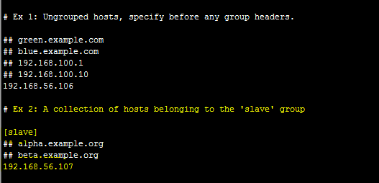

* Run the ping command below to see client nodes are reachable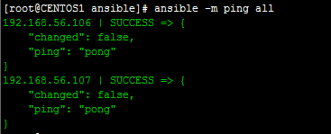

When Ping fails:

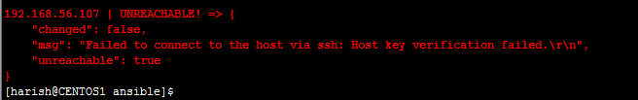

## Steps Involved in Installing MySQL 5.7.xx on RHEL 7

1. Download the MySQL Community/Enterprise RPM’s

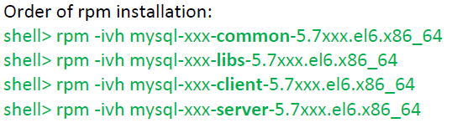

1. Enable and Start MySQL server.
2. Take a backup of my.cnf Configuration file and replace it with tuned my.cnf template file

my.cnf tuning includes:

1. Changing data directory to /data partition

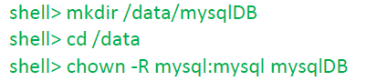

1. Initializing MySQL in new data directory

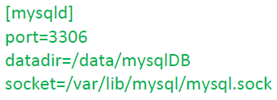

For Installing MySQL in the new data directory, mysqld --initialize is used

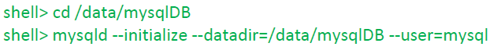

1. Updating parameters like innodb_buffer_pool_size , max_connections , slow_query_log based on server configuration

Sample my.cnf file for reference



1. Change the root password for all MySQL hosts.
2. Restart MySQL Server

## Installation of MySQL in Client Server(s) using Ansible Playbook

Ansible Playbooks are written in ‘yaml’ code, which is executed with below command.

[root@CENTOS1 ansible]# ansible-playbook mysql-repo.yml

Where mysq-repo.yml is the yaml code used for executing the task



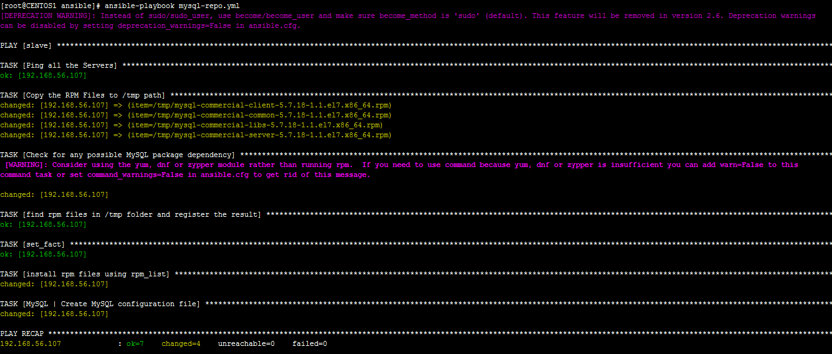

1. Ansible Play-book execution
2. Check MySQL Installation status in client server

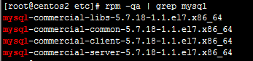

1. Original my.cnf file has been replaced with ‘tuned my.cnf’ file by ansible



1. Check MySQL service status

